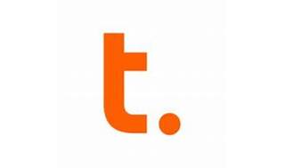

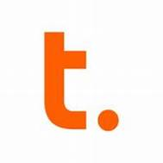

Explore

[**Teradata** is an enterprise software company that develops and sells database analytics software, specializing in large-scale data warehousing applications using parallelism1](https://www.teradata.com/university/overview)[2](https://www.teradata.com/university/academics)[3](https://www.classcentral.com/subject/teradata)[4](https://www.teradata.com/university)[5](https://en.wikipedia.org/wiki/Teradata).

Here are **five free resources** where you can learn more about Teradata:

1. [**Teradata University**](https://www.teradata.com/university/overview): Teradata University offers a collection of online courses, including both free and cost-effective options. [You can explore over 275 courses to build your skills in Teradata1](https://www.teradata.com/university/overview).
2. [**Teradata University for Academics**](https://www.teradata.com/university/academics): Students can access free online training to prepare for careers in data and analytics. [It’s a great platform to learn new skills, complete assignments, and explore job opportunities](https://www.teradata.com/university/overview)[2](https://www.teradata.com/university/academics).
3. [**Coursera**](https://www.classcentral.com/subject/teradata): Coursera provides Teradata courses where you can earn certificates. [Explore reviews to find the right class for you](https://www.teradata.com/university/overview)[3](https://www.classcentral.com/subject/teradata).
4. [**Teradata Learning Resource Center**](https://www.teradata.com/university): This resource hub includes customer education, Teradata certification information, blogs, and more. [You can enhance your Teradata skills through comprehensive training programs](https://www.teradata.com/university/overview)[4](https://www.teradata.com/university).
5. [**GeeksforGeeks**](https://www.geeksforgeeks.org/teradata/): GeeksforGeeks offers insights into advanced SQL, AppCenter, tuning, and Teradata Parallel Transporter. [Dive deeper into Teradata’s features and functionalities](https://www.teradata.com/university/overview)[4](https://www.teradata.com/university).

Happy learning! 🚀